May 14th, 2006
Leonie, Gavin, Nadine
Well, first of all, its ‘Happy Birthday’ to Gavin. Take your pick of birthday cards! (You may have to look up the meaning of ‘perspicacity; -- I did!)

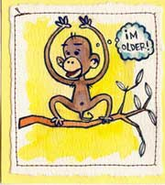
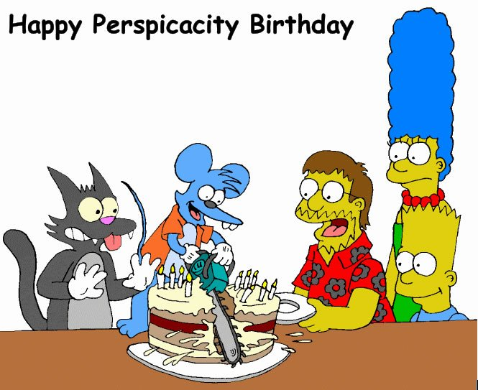

For exercise this past week. I swam three times, doing 1.5 km each time. The other two days I went to the gym and combined weights with 12 minutes of running each time.
Last Monday I had diarrhoea straight after dinner. I think it was caused by an orange and not anything in the dinner itself. Half the orange was soft and rotten looking so I threw that away and ate the rest. But if it was the orange, it certainly acted quite fast.
On Tuesday, I picked up two 'free' soup plates from Park n Shop. Every week for the past few months, the supermarket gave out stickers for purchases so I had accumulated enough to get the two plates. However, the local supermarket had run out so I had to go to another not too far away to get them. But I may not ever use them as there are already enough plates here.
The other day, the hotel carried out its quarterly cleaning of suites. They provide a checklist for the things you want done. I always request for the carpet to be shampooed and the marble floor to be polished. This time I got them to clean the (white) curtains, the chairs and the sofa cover.
On Friday, a ferry went aground on Lantau in broad daylight and with calm seas! Nobody seriously hurt. Hard to imagine. It was not pulling in at a pier or anything like that which might provide some explanation; it just ploughed straight into the island!
There was a report on the TV news the other night that NZ was offered for sale by auction (by an Australian) on e-bay. It was described as having very ordinary weather, and bidding opened at 1 cent. More than 22 bids were posted, with one potential buyer offering A$3000, before eBay noticed and pulled the plug!

The regular matches in the Super 14 were completed this weekend. The Canterbury Crusaders ended up on top with the Wellington Hurricanes second. The top four teams go into the semi-final playoffs next weekend with the final the weekend after.
That’s it for now.
Cheers

